T H E S O N G S

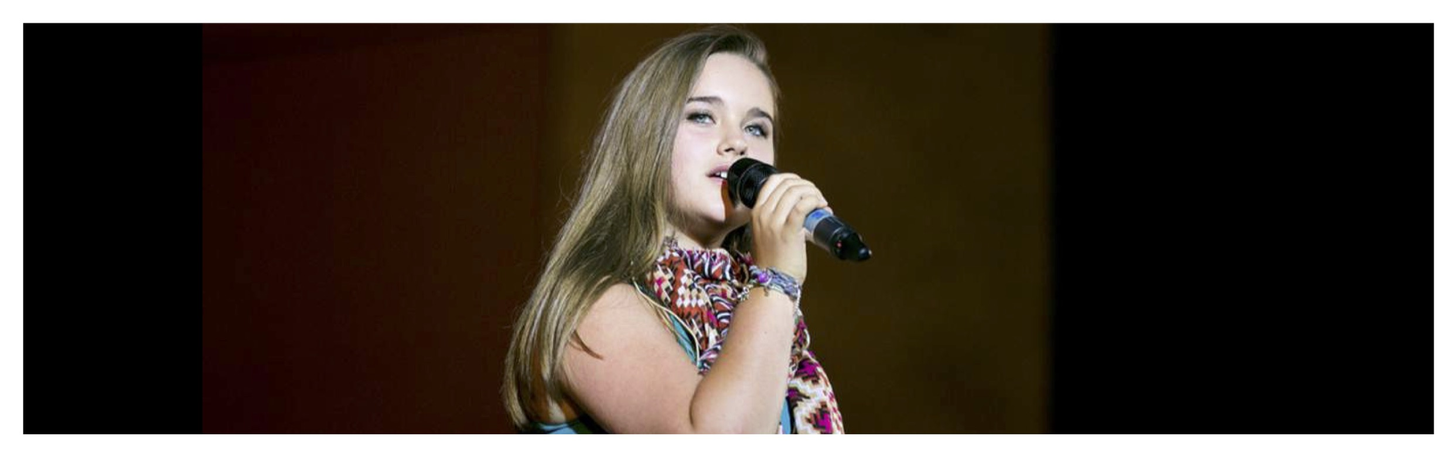

Thea Simpson, one of the Soloists, sings World So Blind at the UN Geneva Show

- World So Blind – Lyric
- World So Blind – PDF Score
- World So Blind – Sibelius Score
- World So Blind – Video
- World So Blind – Audio + Vocal
- World So Blind – Instrumental

World so Blind – Lyric
For every gain there is a natural loss
In every church each temple and each mosque
For every paradise there must be a hell
In every saint the devil dwells
For every mountain there must be a plain
In every sea a piece of land

But what we gonna do when it all runs out
What we gonna say when its too late
Are we going to blame it all on someone else
Just not ourselves??

Hungry children with their sunken eyes
Holding out their hands in vain
Wealthy nations with their mountains of food
Excuses flaunted without shame
No one seems to be responsible
No one wants to take the blame

But what we gonna do when it all runs out
What we gonna say when it’s too late
Are we gonna blame it all on someone else
Just not ourselves??

World so blind!!
Pretending as if nothing is wrong
Hey there man, I’m talking to you
Wait a minute don’t walk away now
Yes it’s you, not someone else on a different floor
I mean you!!
They’ll be breaking down your door
Blaming you forever more!

Little families in their broken down boats
Going for a sail today they’d say
Tankers laden with the wealth of the world
They wave - then turn away

Countries argue over who what where when?
But do they really care?!!
And what we gonna do when it all runs out??
What we gonna say when it’s too late?
Are we gonna blame it all on someone else
Just not ourselves??

World so blind!!
Pretending as if nothing is wrong
Hey there man, I’m talking to you
Wait a minute - don’t turn away now
Yes it’s you!
Not someone else on a different floor
I mean you!!
They’ll be breaking down your door
Blaming you forever more.

World so blind!!
Pretending as if nothing is wrong
Hey there man, I’m talking to you
Wait a minute - don’t turn away now
Yes it’s you!!
Not someone else on a different floor
I mean you!
They’ll be breaking down your door
Blaming you forever more.

